UK Road Safety Analysis
Data Science Report — 2019 Accident Data
Prepared for the Department for Transport (DfT)

Question 1 — General Accident Patterns
This section analyses the temporal distribution of all road traffic accidents recorded in England in 2019, with a focus on identifying patterns across hours of the day and days of the week. The findings are intended to inform targeted road safety interventions by the Department for Transport.

1.1 Accidents by Hour of Day
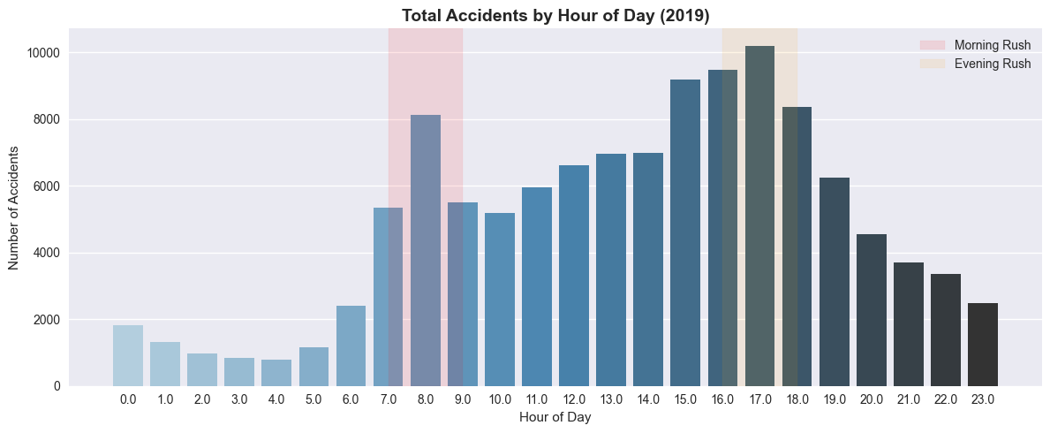
Figure 1.1 — Total road traffic accidents by hour of day, England 2019. Shaded regions indicate morning (red) and evening (orange) rush hours.

Finding
Accident frequency follows a clear bimodal distribution across the 24-hour day. The first peak occurs between 8am and 9am, and the most pronounced peak between 5pm and 6pm, both corresponding directly to the morning and evening commuter rush hours. Accidents fall to their lowest levels between midnight and 6am.

Explanation
The pattern is consistent with the rhythm of the working day. Higher traffic volumes during commuter hours naturally increase the probability of collisions. The evening peak is larger than the morning peak, likely due to driver fatigue at the end of the working day and deteriorating light conditions in autumn and winter. The near-absence of accidents in the early hours reflects significantly reduced traffic volumes overnight.
Policy Implication: The Department for Transport should prioritise road safety interventions — including variable speed limits, targeted enforcement, and public transport incentives — during the 7–9am and 4–7pm windows, particularly on high-volume urban and arterial routes.

1.2 Accidents by Day of Week
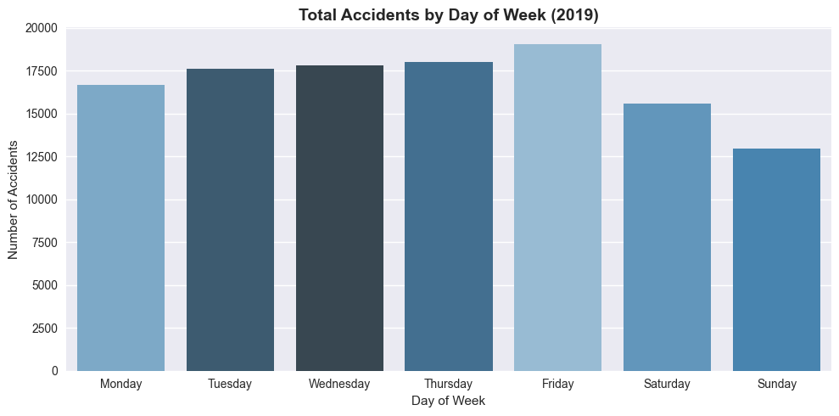
Figure 1.2 — Total road traffic accidents by day of the week, England 2019.

Finding
Accidents are broadly consistent across the working week (Monday to Friday), with Friday recording the highest number of accidents of any single day. Saturday and Sunday both show noticeably lower accident counts compared to weekdays.

Explanation
The elevated weekday counts reflect the dominance of commuter traffic as the primary driver of accident frequency. Friday's peak may be attributed to higher traffic volumes combined with end-of-week driver fatigue and increased social journeys. The lower weekend counts indicate that vehicle volume — rather than risky driving behaviour — is the more significant contributor to overall accident frequency.
Policy Implication: Friday should be treated as the highest-priority day for traffic management and enforcement. Targeted campaign messaging around driver fatigue and journey planning should be directed specifically at Friday afternoon and early evening travel periods.

1.3 Accident Heatmap — Hour vs Day of Week
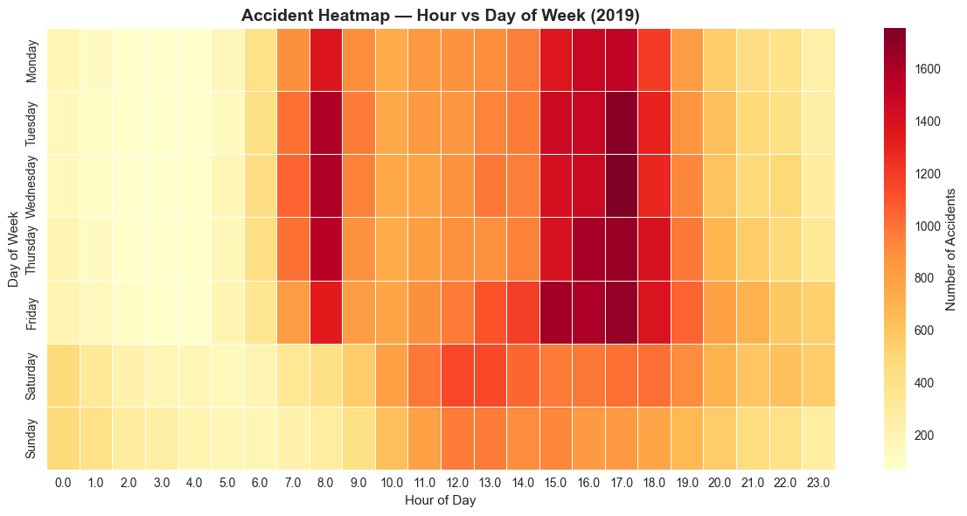
Figure 1.3 — Heatmap of accident frequency by hour of day and day of week, England 2019. Darker cells represent higher accident concentrations.

Finding
The heatmap reveals that the single highest accident concentration occurs on Friday between 5pm and 6pm. A consistent high-risk band runs across weekday mornings between 8am and 9am from Monday to Friday. A secondary, lower-intensity cluster is visible on Friday and Saturday nights between 10pm and midnight, representing a distinct risk pattern outside the commuter peaks.

Explanation
The Friday evening cell represents the most dangerous single time-slot on British roads in 2019, combining peak commuter traffic with the start of weekend leisure travel. The consistent weekday morning band confirms the commuter rush effect identified in Figure 1.1. The late-night Friday and Saturday cluster is characteristic of nightlife-related journeys, where driver impairment and fatigue are elevated risk factors despite lower overall traffic volumes.
Policy Implication: A time-specific approach to resource deployment would be substantially more effective than blanket measures. Enforcement and safety resources should be concentrated on Friday evenings as the primary high-risk window, with a secondary focus on late Friday and Saturday nights in urban centres.

1.4 Summary of Key Recommendations
Recommendation 1: Introduce time-variable speed limits and increased enforcement on major urban routes during the 7–9am and 4–7pm rush hour windows on weekdays.
Recommendation 2: Target Friday evening (4–8pm) as the single highest-risk period for road safety campaigns, targeted enforcement, and active traffic management.
Recommendation 3: Deploy late-night road safety resources in urban centres on Friday and Saturday nights to address impairment and fatigue-related incidents outside of commuter hours.
Recommendation 4: Promote public transport and active travel alternatives for commuter journeys, particularly on Fridays, to reduce peak-hour vehicle volumes on high-risk routes.

